Kevin Punatar

Dhaval Patel

ITMD 411 Final Project

**Instructions:**

The Final Project GUI.jar file is in the enclosed file. The .java files are also included.

When initially starting the program, click “Create Account” first to create a new user.

Follow the required steps to create an account, and then use those login credentials to enter the user account.

**Notice:** The admin need not create a new account. The admin’s account is hardcoded with the username “admin” and password “admin”

The admin has more viewing privileges than a normal user, as you will be able to see in the program.

**Very Important: when logging out, DO NOT click the “x” to exit. You must click “File” and then “Log Off.”**

**Program:**

Creating user named Kevin Punatar:

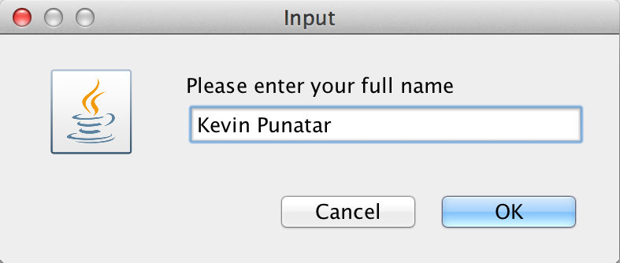 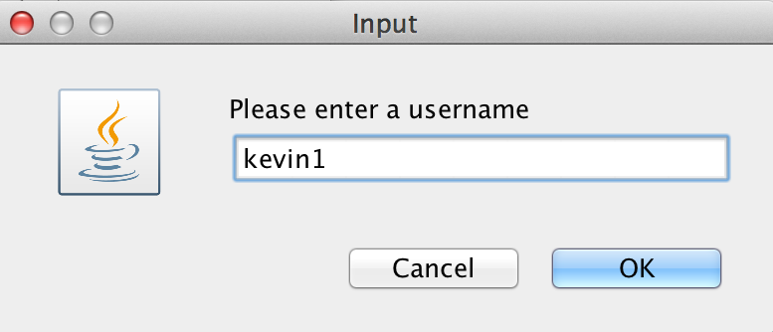

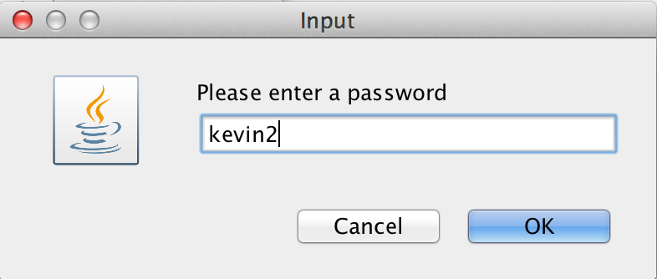

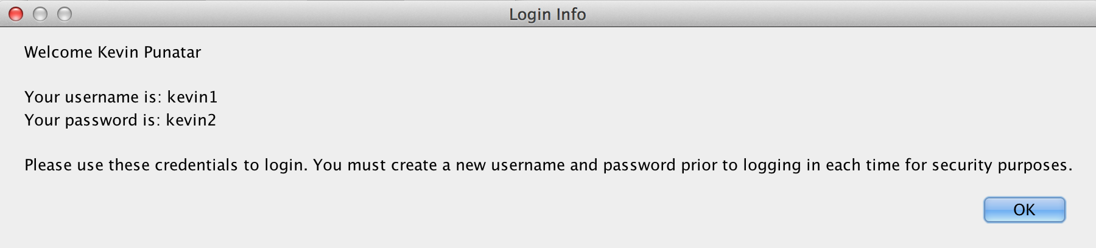

Account created for Kevin Punatar with the Login credentials he made.

Kevin Punatar is logging in with the user and password he created:

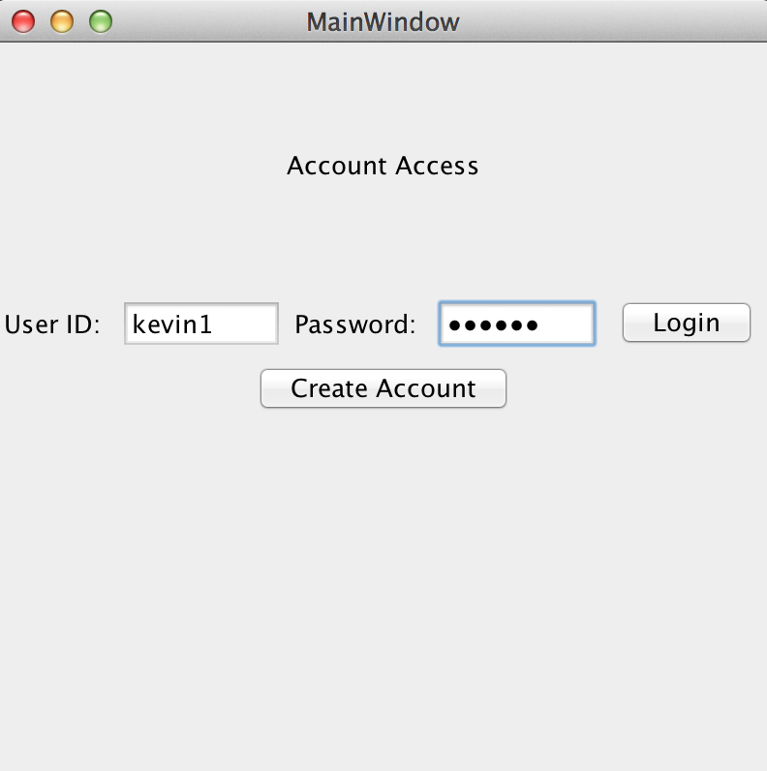

If either the username or password is not correct, this event handler would pop up:

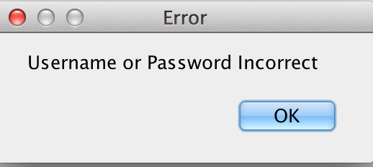

**Kevin Punatar** is logged in and is now creating a trouble ticket with his name and issue:

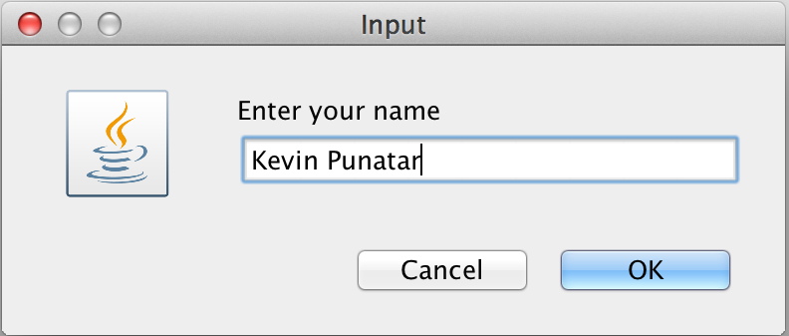 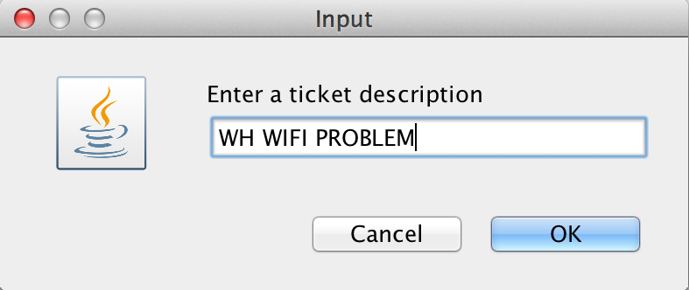

A ticket ID is then provided to him:

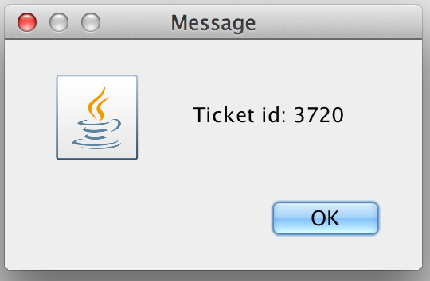

The ticket 3720 is now created. The ID is posted along with the name of the person that created it, the issue, the date it was created, and the status of “Open”:

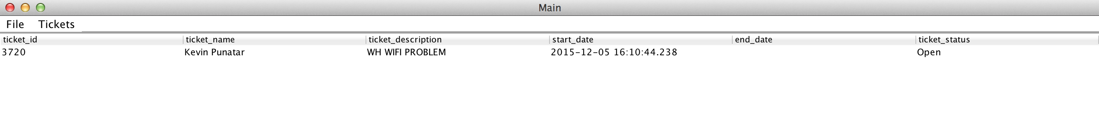

To skip redundant steps, we followed the same “Create Account” procedure for 4 more users.

You will now see the trouble ticket creation for each…

**John Johnson** is logged in and is now creating a trouble ticket with his name and issue:

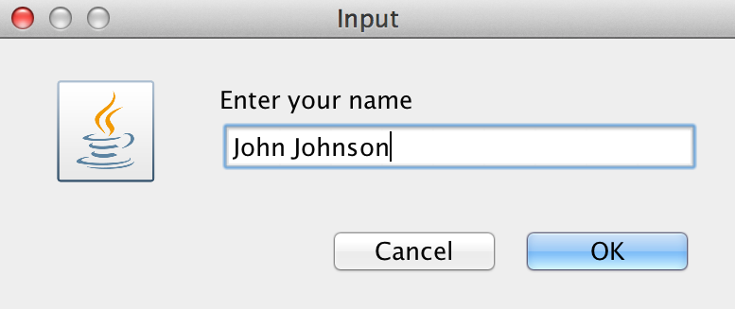 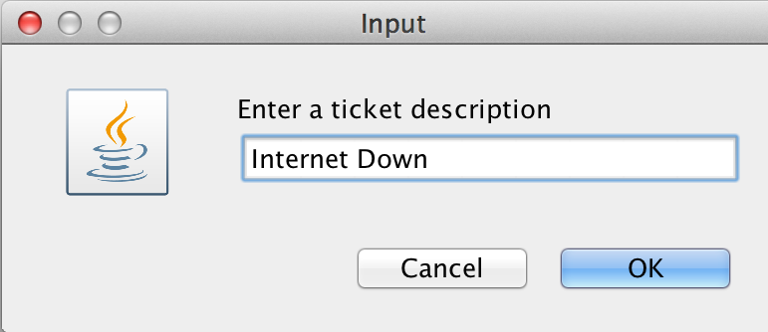

A ticket ID is then provided to him:

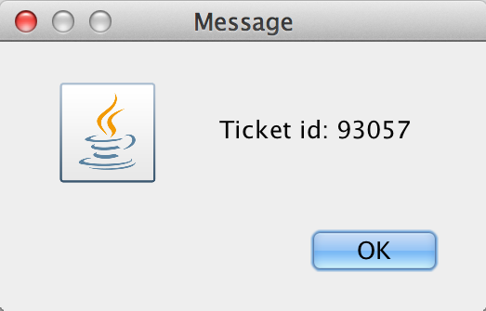

The ticket 93057 is now created. The ID is posted along with the name of the person that created it, the issue, the date it was created, and the status of “Open”:

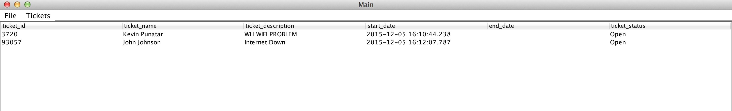

**Dhaval Patel** is logged in and is now creating a trouble ticket with his name and issue:

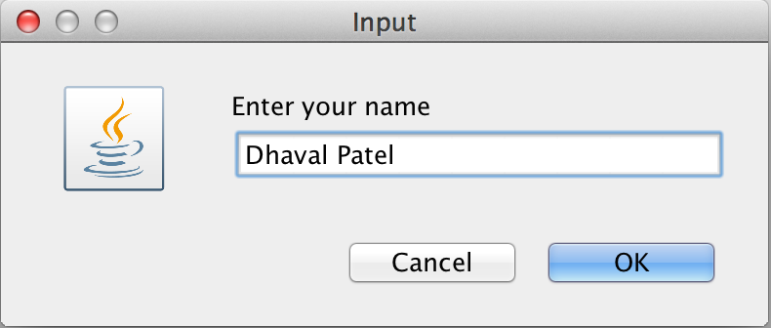 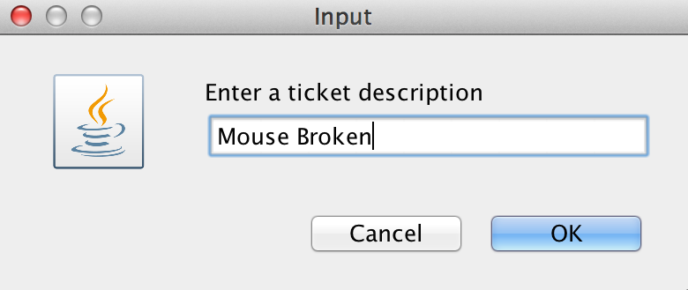

A ticket ID is then provided to him:

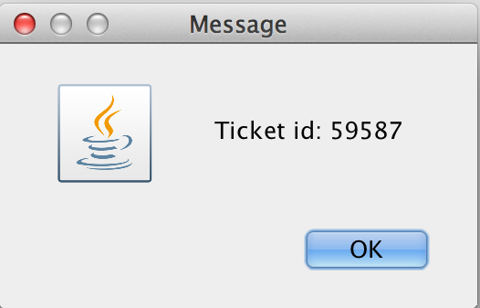

The ticket 59587 is now created. The ID is posted along with the name of the person that created it, the issue, the date it was created, and the status of “Open”:

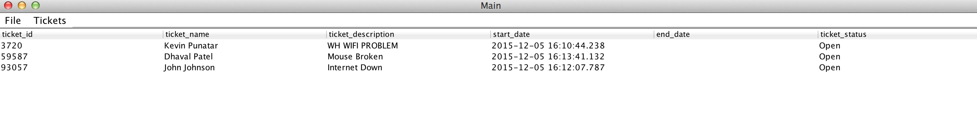

**Mike Miky** is logged in and is now creating a trouble ticket with his name and issue:

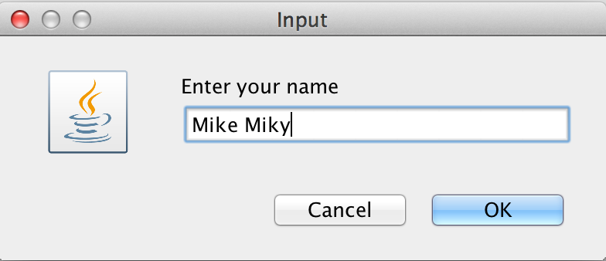 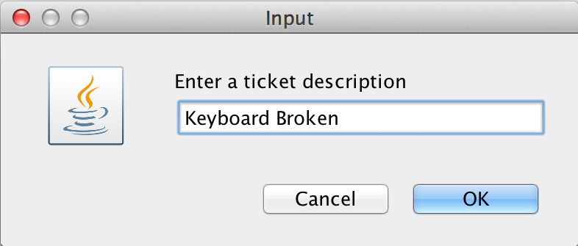

A ticket ID is then provided to him:

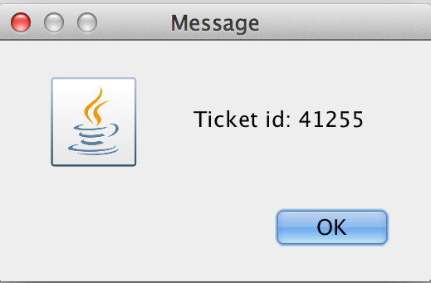

The ticket 41255 is now created. The ID is posted along with the name of the person that created it, the issue, the date it was created, and the status of “Open”:



**Mary Morris** is logged in and is now creating a trouble ticket with her name and issue: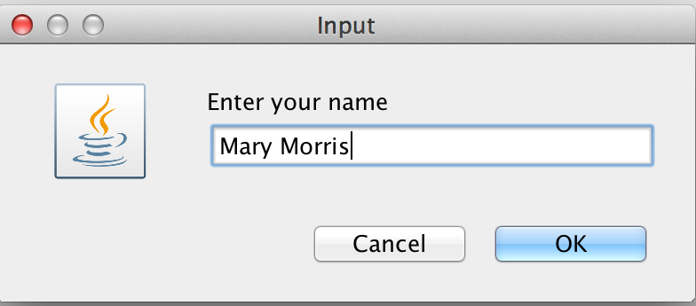 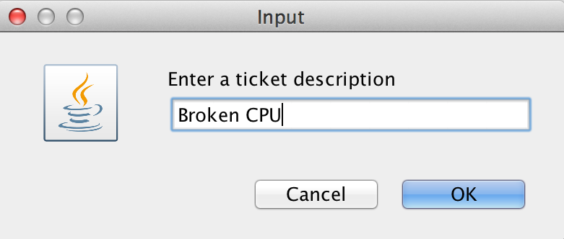

A ticket ID is then provided to her: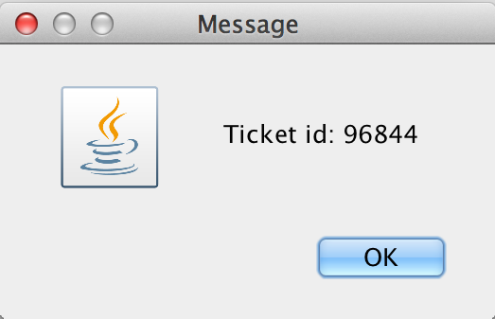

The ticket 96844 is now created. The ID is posted along with the name of the person that created it, the issue, the date it was created, and the status of “Open”:

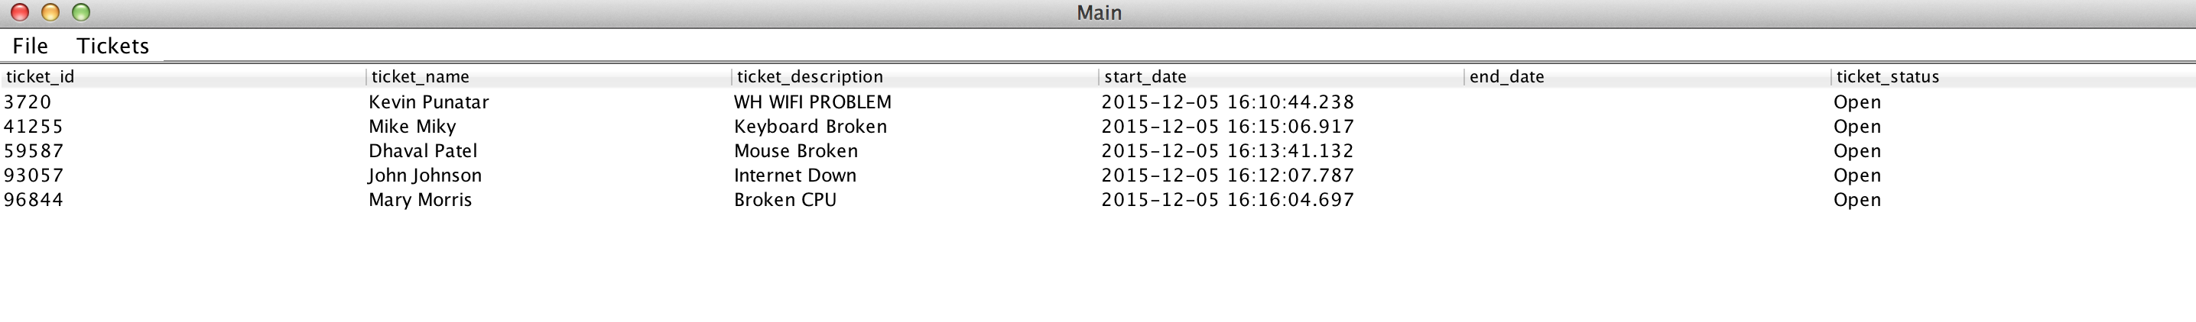

Now Mary is trying to delete the ticket she entered:

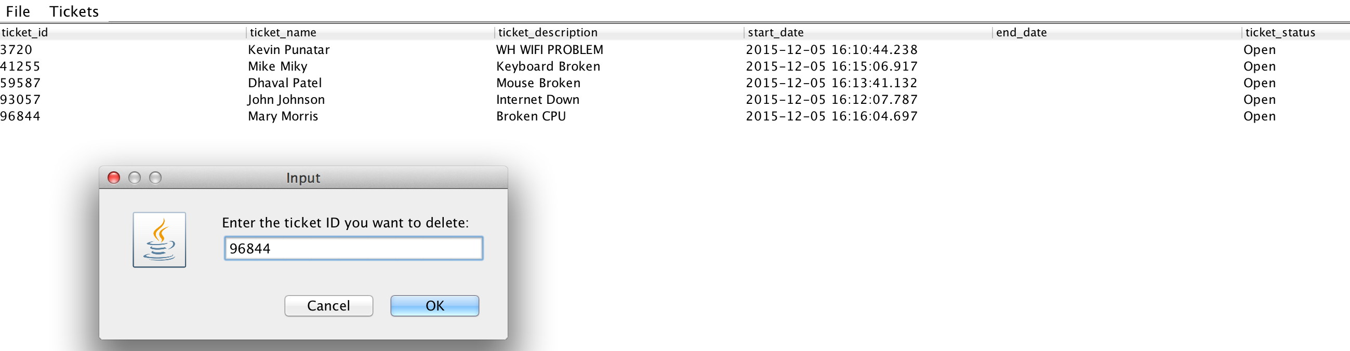

She is asked to type “yes” to confirm her deletion:

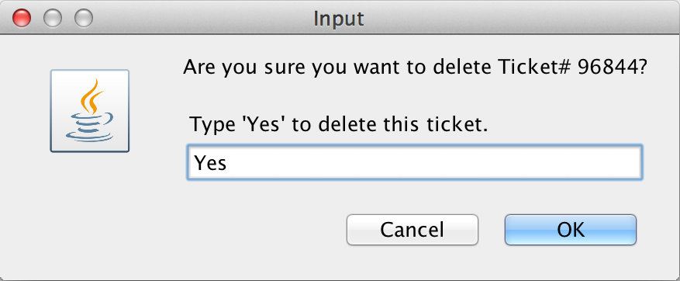

If she were to type anything other than “yes,” this event handler would pop up:

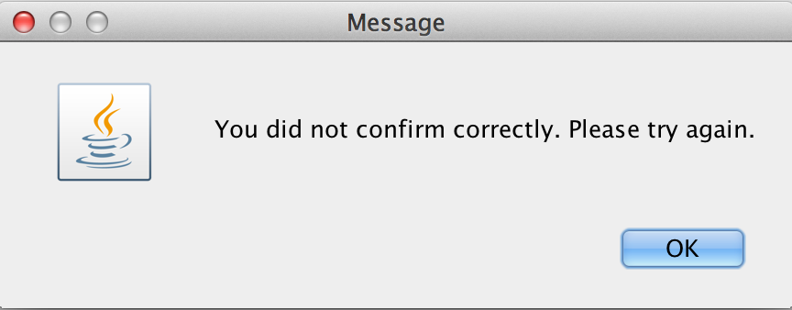

The deletion has been confirmed:

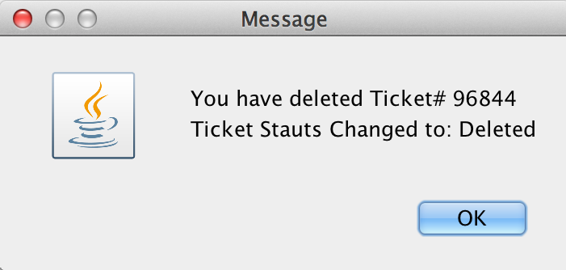

You can see that the fluid GUI updates the “View Ticket” page by putting an end date to Mary’s ticket as well as changing the status to “Deleted”:

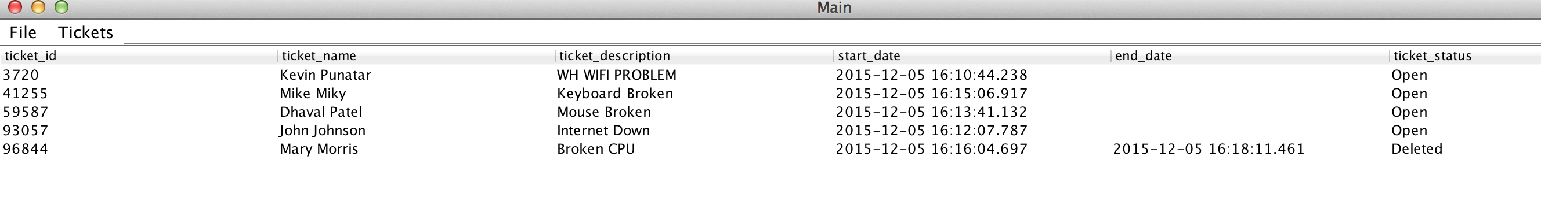

The admin now logs in to check on the ticket system:

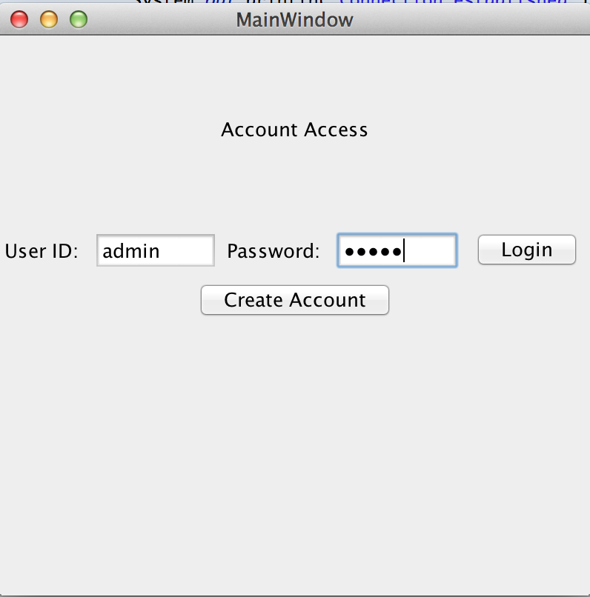

The admin can see all of the open tickets in “View Ticket”:

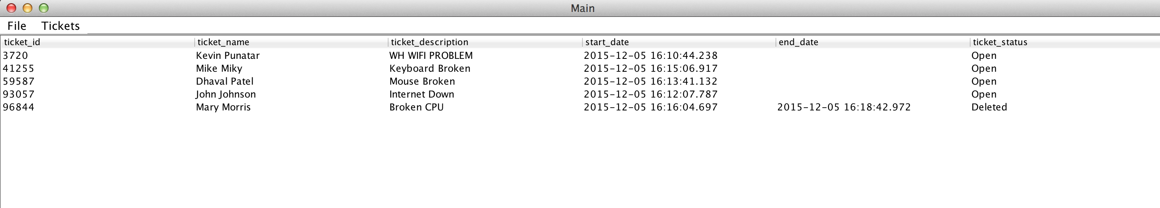

The admin clicks “Delete Ticket” and wants to delete ticket 3720:

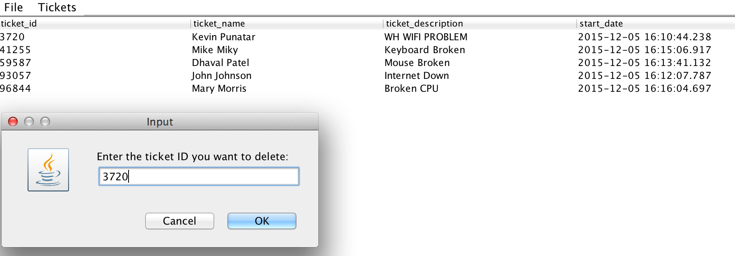

The admin is asked to confirm by typing “yes”:

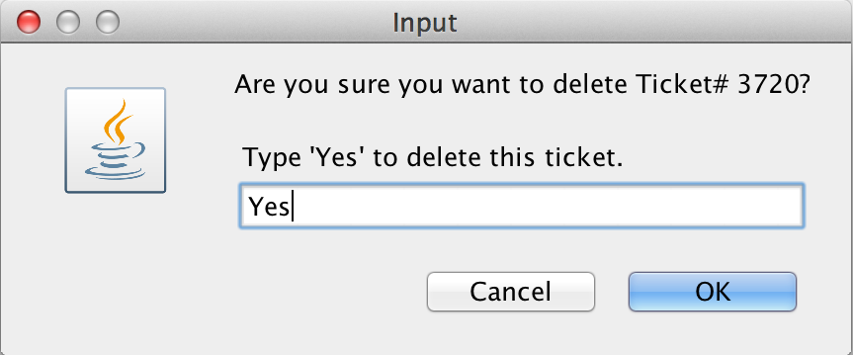

If the admin were to type anything other than “yes,” this event handler would pop up:



The admin has now deleted ticket 3720:

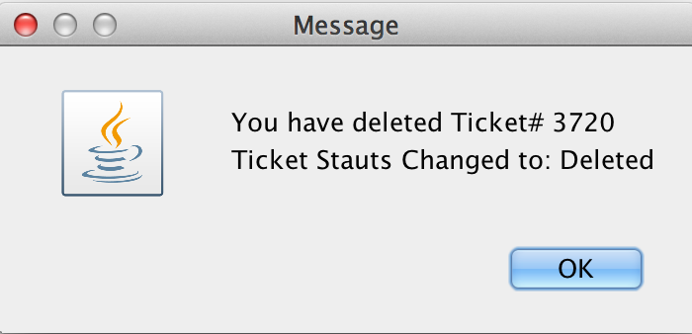

You can see that the fluid GUI updates the “View Ticket” page by putting an end date to ticket 3720 as well as changing the status to “Deleted”:

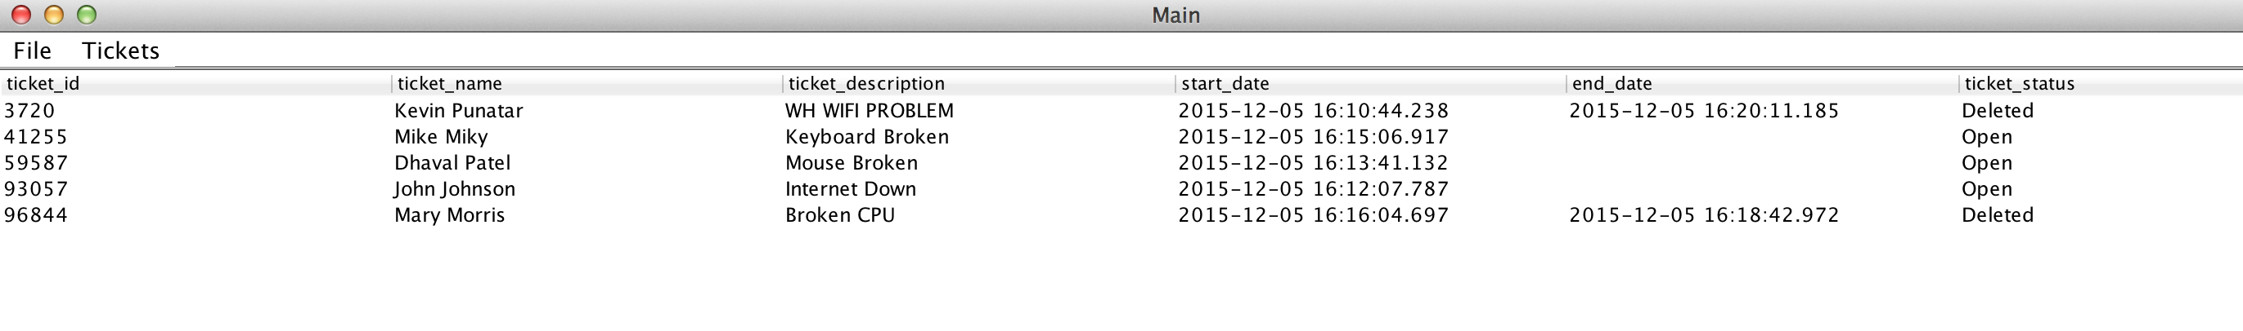

The admin wants to now end ticket 41255 by going into “Admin: End Ticket”:

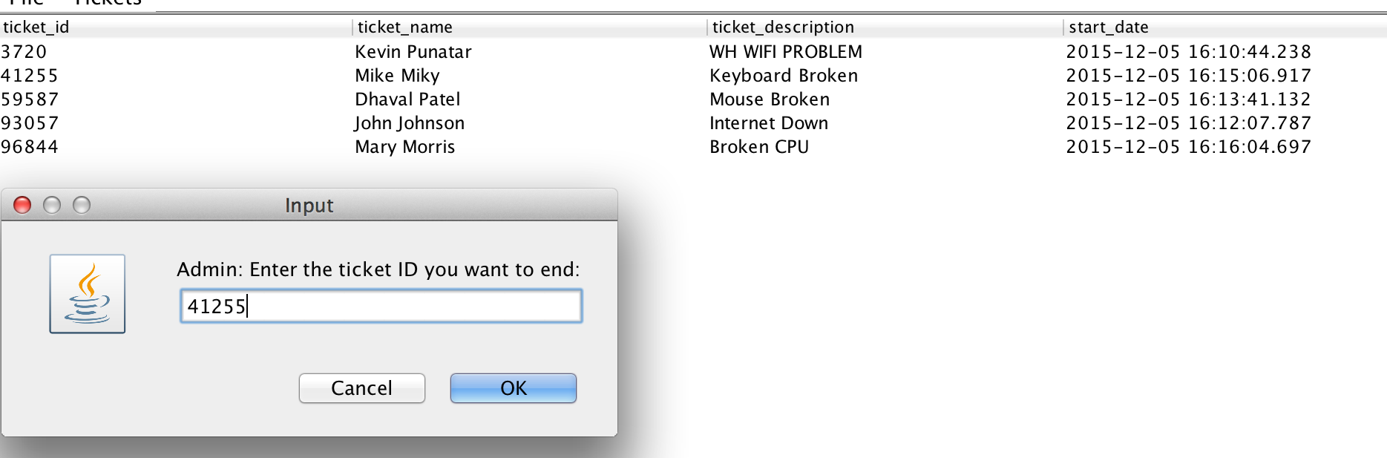

The admin is asked to confirm by typing “yes”:

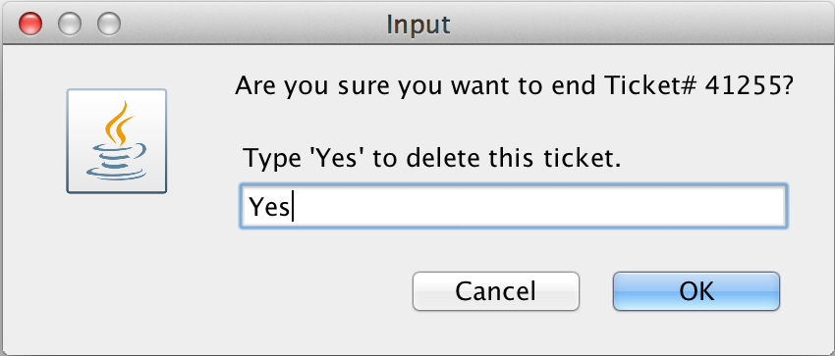

If the admin were to type anything other than “yes,” this event handler would pop up:



The admin has now deleted ticket 41255:

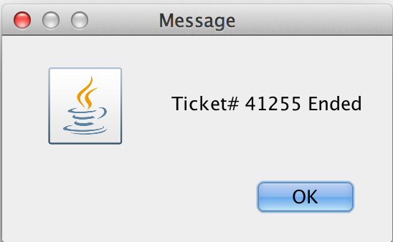

You can see that the fluid GUI updates the “View Ticket” page by putting an end date to ticket 41255 as well as changing the status to “Closed”:

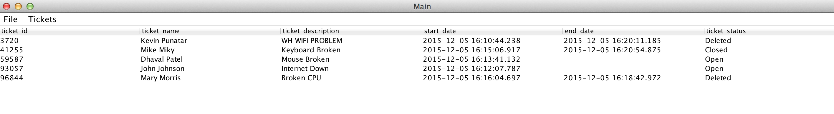

The admin wants to now change the ticket status of 59587 by going into “Admin: Change Ticket Status”:

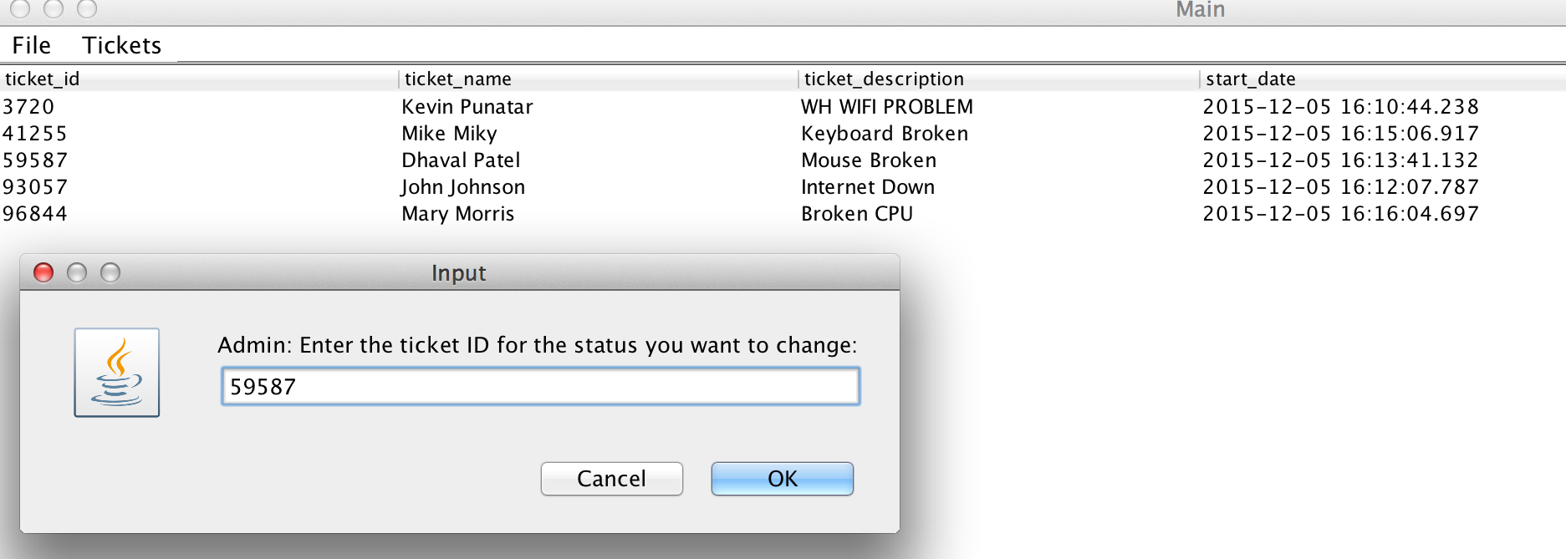

The admin is asked to type a status from the options:

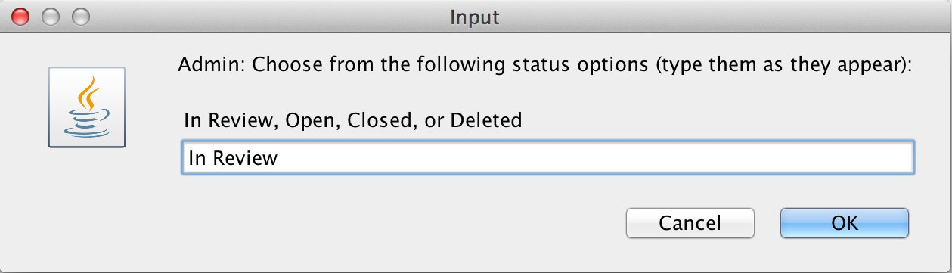

The status was changed to “In Review” for ticket 59587:

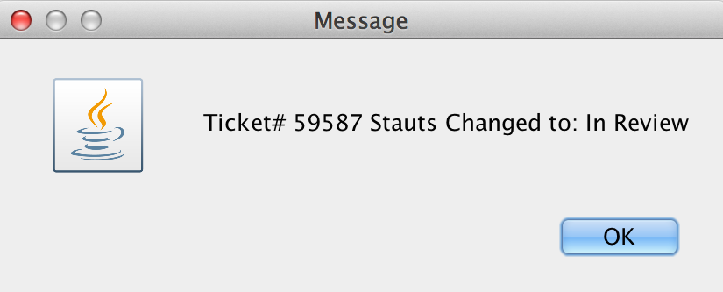

You can see that the fluid GUI updates the “View Ticket” page by changing the status to “In Review”:

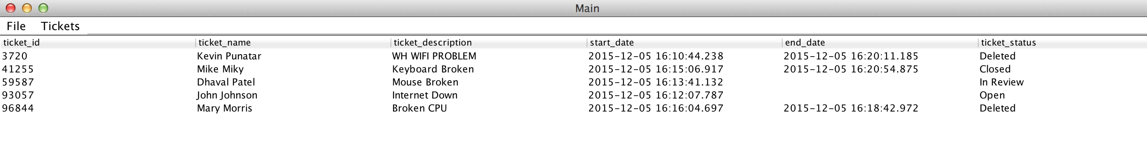

The admin can click on “Admin: Check Login Info” to see the names of the users that created accounts, their username, password and the date they created the account.

